**30-01-2018**

**RESEARCH INFOTECH**

**DAILY ANALYSIS**

|  |
| --- |
| http://researchinfotech.co.in/storage/images/logo.pngImage result for SEBI |

|  |
| --- |
| **RELIANCE INDUSTRIAL INFRASTRUCTURE LTD (NSE-RIIL)** |

|  |  |  |
| --- | --- | --- |
| **BUY** | **543-545V** | **SL-700** |
| **TGT 1- 760** | **TGT 2- 800** | **SL-700** |

|  |  |  |  |  |
| --- | --- | --- | --- | --- |
| **S2** | **S1** | **PP** | **R1** | **R2** |
| **640** | **690** | **730** | **760** | **820** |

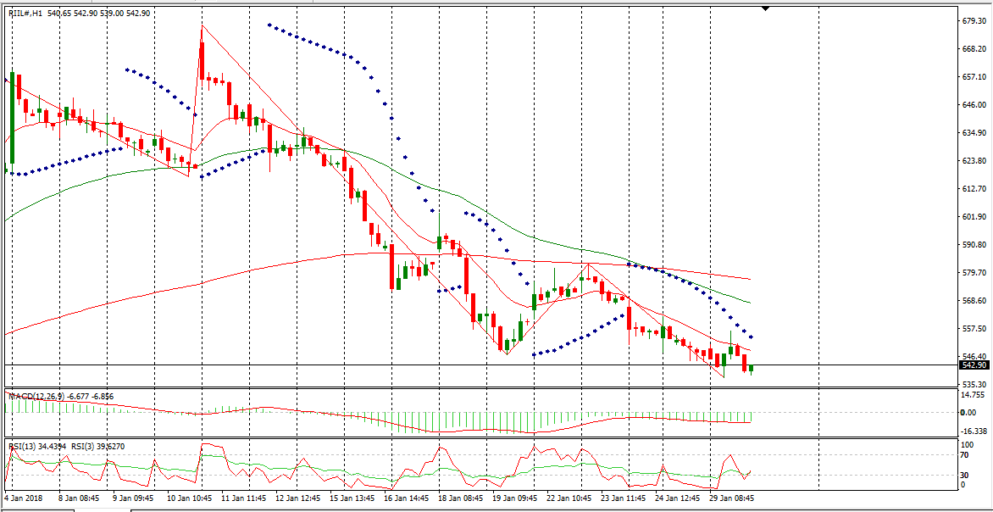

**DESCRIPTION**

Reliance Industrial Infrastructure Limited is engaged in infrastructure activity in India. The Company is engaged in providing services of transportation of petroleum products and raw water through its pipelines, operating construction machinery on hire and other infrastructure support services. Its products/services include product transportation services, hiring of construction machineries and information technology (IT) support services.  
 It has its operations mainly in the Mumbai and the Rasayani regions of Maharashtra, Surat, and Jamnagar belts of Gujarat. It is also engaged in related activities involving leasing and providing services connected with computer software and data processing.   
The Company has set up an approximately 200-millimeter diameter twin pipeline system from the Refinery of Bharat Petroleum Corporation at Mahul, Mumbai, for transporting petroleum products, such as Naphtha and Kerosene to the Petrochemical Complex of Reliance Industries Limited at Patalganga.

|  |
| --- |
| http://researchinfotech.co.in/storage/images/logo.pngImage result for SEBI |

**TECHNICAL VIEW**

* In daily candle RIIL was looking strong, it was taking support of its 55 day’s EMA and looking bullish.
* From the opening it was falling down but near closing in hourly candle stick it made bullish hanging man, it took support of its short term moving average and I saw fresh buying near closing.
* In short term its structure was also looking bullish.
* In daily candle it was taking support of its day’s low also and looking reversal, next trading it can be gap up opening.
* Above its moving avg it made a bullish candle in daily candle stick chart pattern.
* Its daily candle it made three bearish brekaway.

**RECENT NEWS**

* Reliance Infrastructure Wins Rs 882 Cr Order From NHAI.
* Reliance Infrastructure, the construction arm of the Anil Ambani Group, said it received a Rs 882 cr order for six-laning a 70 km stretch on National Highway 2 in Bihar.
* As the trading hours came to an end Reliance Industrial Infrastructure Ltd. was observed to be priced at Rs. 539.1 which was 2 points higher than the day's low and 19.35 points lower than the day's high while the day low was Rs. 537.1 and day high was Rs. 558.45 .
* A total of 356,294 shares were traded by this time of the day with the 5 day average volume being 498,529 , 10 day average volume being 587,128 and 30 day average volume being 1,270,700 .
* esterday, Reliance Industrial Infrastructure Ltd. stock closed at Rs. 546.85 while touching a maximum of Rs. 561.80 which was 6.8 points more than the opening price.
* Also, the lowest price which was Rs. 542.35 went 12.65 points lower than the opening price.
* As the trading hours came to an end, the last volume was of 322,582 stocks while the 5 day average volume was 559,109 , the 10 day average volume was of 880,767 stocks and the 30 day average volume was of 1,274,423 stocks.
* The 5 day average volume fell 60768 stocks, 10 day average volume fell 23256 stocks and 30 day average volume fell 12053 stocks when compared to the previous day’s values.

## **DISCLOSURE**

RESEARCH INFOTECH DO NOT RECEIVE ANY CONSIDERATION BY WAY OF REMUNERATION OR COMPENSATION OR IN ANY OTHER FORM WHATSOEVER, BY US OR ANY OF OUR ASSOCIATES OR SUBSIDIARIES FOR ANY DISTRIBUTION OR EXECUTION SERVICES IN RESPECT OF THE PRODUCTS OR SECURITIES FOR WHICH THE INVESTMENT ADVICE IS PROVIDED TO THE CLIENT.

RESEARCH INFOTECH DO NOT RECOMMEND A STOCK/COMMODITY BROKER. IF ANY STOCK/COMMODITY BROKER IS RECOMMENDED BY ANY OF OUR REPRESENTATIVE, WE DO NOT RECEIVE ANY CONSIDERATION BY WAY OF REMUNERATION OR COMPENSATION OR IN ANY OTHER FORM WHATSOEVER FROM STOCK/COMMODITY BROKER OR ANY OTHER INTERMEDIARY SO RECOMMENDED TO CLIENT.

TO ENSURE COMPLIANCE WITH THE INVESTMENT ADVISOR REGULATIONS 2013, WE HAVE RESOLVED THAT THE INVESTMENT ADVISOR AND ALL ITS REPRESENTATIVES WILL NOT MAKE ANY TRADES IN THE MARKET. WE ARE NOT ASSOCIATED IN ANY MANNER WITH ANY ISSUER OF PRODUCTS/ SECURITIES, THIS ENSURES THAT THERE IS NO ACTUAL OR POTENTIAL CONFLICTS OF INTEREST. THIS ALSO ENSURES THAT OBJECTIVITY OR INDEPENDENCE IN THE CARRYING ON OF INVESTMENT ADVISORY SERVICES IS NOT COMPROMISED. INVESTMENT IN STOCK/COMMODITY MARKETS IS SUBJECT TO MARKET RISK, THOUGH BEST ATTEMPTS ARE MADE FOR PREDICTING MARKETS, BUT NO SURETY OF RETURN OR ACCURACY OF ANY KIND IS GUARANTEED, WHILE THE PERFORMANCE SHEET OF VARIOUS PRODUCTS IS AVAILABLE BUT SHOULD NOT BE CONSIDERED AS A GUARANTEE FOR FUTURE PERFORMANCE OF THE PRODUCTS/SERVICES. CLIENTS ARE ADVISED TO CONSIDER ALL THE ADVICE AS JUST AN OPINION AND MAKE INVESTMENT DECISION ON THEIR OWN.

IN CASE OF CLIENTS SEEKING ADVICE ON ANY SPECIFIC POSITIONS ALREADY MADE BY THE CLIENT, WE WILL BE ABLE TO SUGGEST BEST POSSIBLE ACTION CONSIDERING OUR VIEW ON THE SECURITY OR PRODUCT. SUCH SUGGESTION UNDER ANY CIRCUMSTANCES SHALL BE CONSIDERED AS AN OPINION (NOT ADVICE) FROM OUR ORGANIZATION AND WE ADVISE CLIENT TO CONSIDER OUR OPINION AND NOT CONSULTANCY TO MAKE HIS/HER FINAL DECISION. WE ARE NOT LIABLE FOR ANY LOSSES WHATSOEVER CLIENT MAY INCUR IN ACCEPTING THIS OPINION.

CLIENT IS ALSO ADVISED TO TRADE ONLY IF TIPS SUIT HIS CURRENT RISK APPETITE AND RISK BEARING CAPACITY, ALL SUCH TIPS SHALL BE CONSIDERED AS A VIEW OR OPINION AND CLIENT SHALL ON HIS/HER DISCRETION DECIDE ACTUAL TRADES.

WE ARE NOT ASSOCIATED WITH ANY INTERMEDIARIES AND DO NOT RECOMMEND SERVICES OF ANY SPECIFIC INTERMEDIARIES.  
NO LITIGATIONS HAVE BEEN FILED AGAINST US SINCE THE INCORPORATION.

ALL THE TIPS WHICH ARE SUGGESTED BY US ARE COMMUNICATED IN WRITTEN, NO VERBAL COMMUNICATION FROM ANY OF THE EXECUTIVES OR OTHERWISE UNDER ANY CIRCUMSTANCES SHALL BE CONSIDERED AS ADVICE BY OUR ORGANIZATION.